Format Number 002

മത പരിവർത്തന സർട്ടിഫിക്കറ്റ് (ഇംഗ്ലീഷ്)
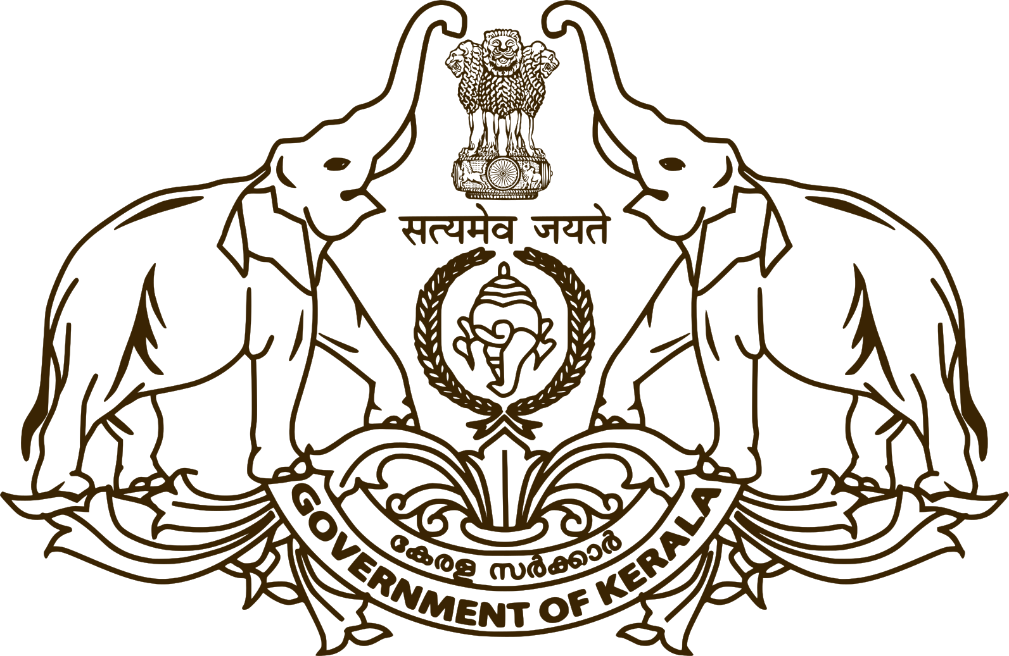
Taluk Office, …………
File No -  Certificate No - | Date - #ApprovedDate#

Certificate
This is to certify that it has been confirmed, based on Community Certificate No. ………………………. Issued by church and the investigation report received from the …………………. Village Officer, that Mr/Miss/Kumary …………… has converted from ……………….. to ………………...
It has also been confirmed that the individual is currently living under the name of Mr / Miss / Kumari ………………….., as per the customs and traditions of the ……………………., at the address ……………….
This certificate is being issued at the request of the applicant for the purpose of ……………………………………………
#ApprovedByName#
#ApprovedByDesignation#

Note – This certificate is digitally signed online so manual signature and seal are not required. Authenticity of this certificate can be checked at https://eoffice.kerala.gov.in

