കൈവശാവകാശ സർട്ടിഫിക്കറ്റ് (ഇംഗ്ലീഷ്) മാതൃക
Form 1
Goverment Of Kerala
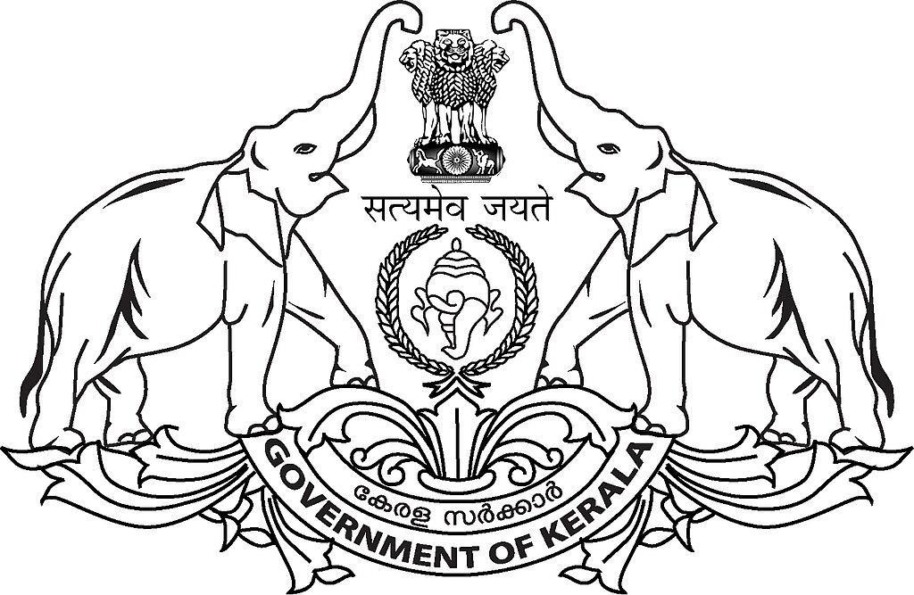
Taluk Office / Village Office, xxxxxxxx
Possession Certificate
Number: |  |  |  |  |  | Date :
Name of the person to whom the certificate is issued
Father's / Mother's / Parent's Name
Address
Post Office (including Pincode)
District
Certifies that the property described in the list below is in the possession and enjoyment of full ownership by the person whose particulars have been appended above.
Taluk, Village | Old Survey Number | Resurvey Block | Resurvey |  | Area (Hec) | TP Number | TP Holders | Land Type
Taluk, Village | Old Survey Number | Resurvey Block | Number | Sub Division Number
This certificate is prepared on the basis of the particulars given in the application, local enquiry, facts and documents produced. The authorized officer shall have the power to cancel this certificate without any warning if any particulars given in the above application or documents are subsequently noticed to be incorrect.
Designation of the Certifying Officer
For what purpose the certificate is issued
Remarks
Signature of the Certifiying Officer

