Format Number 007

നോൺ-ക്രീമി ലെയർ സർട്ടിഫിക്കറ്റ് മാതൃക
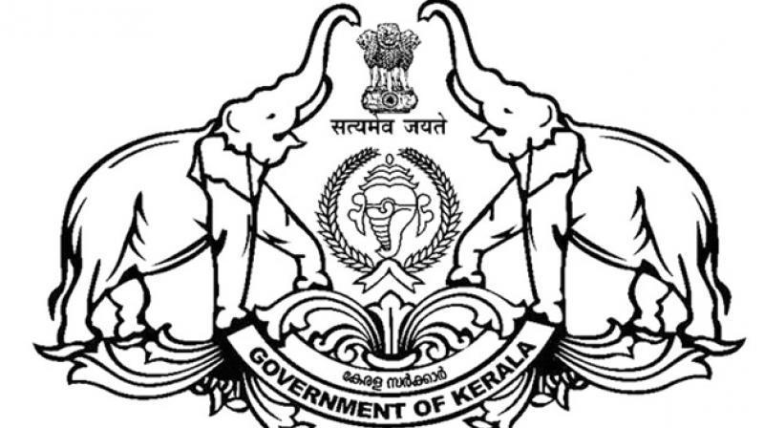
Annexure - XXVII
Government Of Kerala
(Village Office - XXXXXXXXX)
NON - CREAMY LAYER CERTIFICATE
(State Educational Purpose)
No.xxxxxxx Date - XXXXXXX
This is to certify that the person with the following details belongs to the community which is designated as a Backward Class in the State of Kerala and does not belong to the category of ‘Creamy Layer’ in the light of guideline issued in [G.O(P)No.1/2015/BCDD Dated 01-01-2015] and the schedule (s) prescribed there under to identify the ‘Creamy Layer’ among the designated ‘Socially and Educationally Backward Classes’ in the State of Kerala.

Name of Person Whom Certificate Issued | XXXXXXXXXXXXXX
Gender | XXXXXXXXXXXXXX
Name of Father | XXXXXXXXXXXXXX
Address | XXXXXXXXXXXXXX
Post Office with Pin Code | XXXXXXXXXXXXXX
Name Of Local Body | XXXXXXXXXXXXXX
Village | XXXXXXXXXXXXXX
Taluk | XXXXXXXXXXXXXX
District | XXXXXXXXXXXXXX
Religion | XXXXXXXXXXXXXX
Caste | XXXXXXXXXXXXXX
Date of Issue of Certificate | XXXXXXXXXXXXXX
Designation of the Issuing Officer | XXXXXXXXXXXXXX
Place - XXXXXXXXXXXXXX
Signature & Name of the Officer
Date - xx/xx/xxxx

Office Seal

